东华学报
2025年第42卷第4期
──────────────────────────────
本期责编: 编辑部 | 2025年12月01日

10.19884/j.1672-5220.202404007
────────────────────
作者说链接/OSID

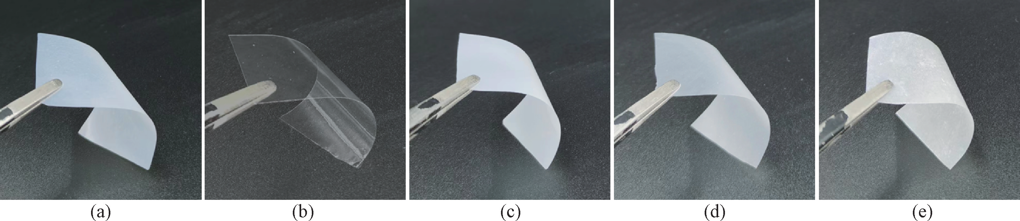
WU Xiaoyan, SONG Wei, CHEN Shuang, XIAO Ru
Citation: WU X O, SONG W, CHEN S, et al.. Preparation and Properties of Bacterial Cellulose / Hyaluronic Acid Oral Disintegrating Films [J]. Journal of Donghua University (English Edition), 2025, 42(4): 339-347.

10.19884/j.1672-5220.202406006
────────────────────
作者说链接/OSID

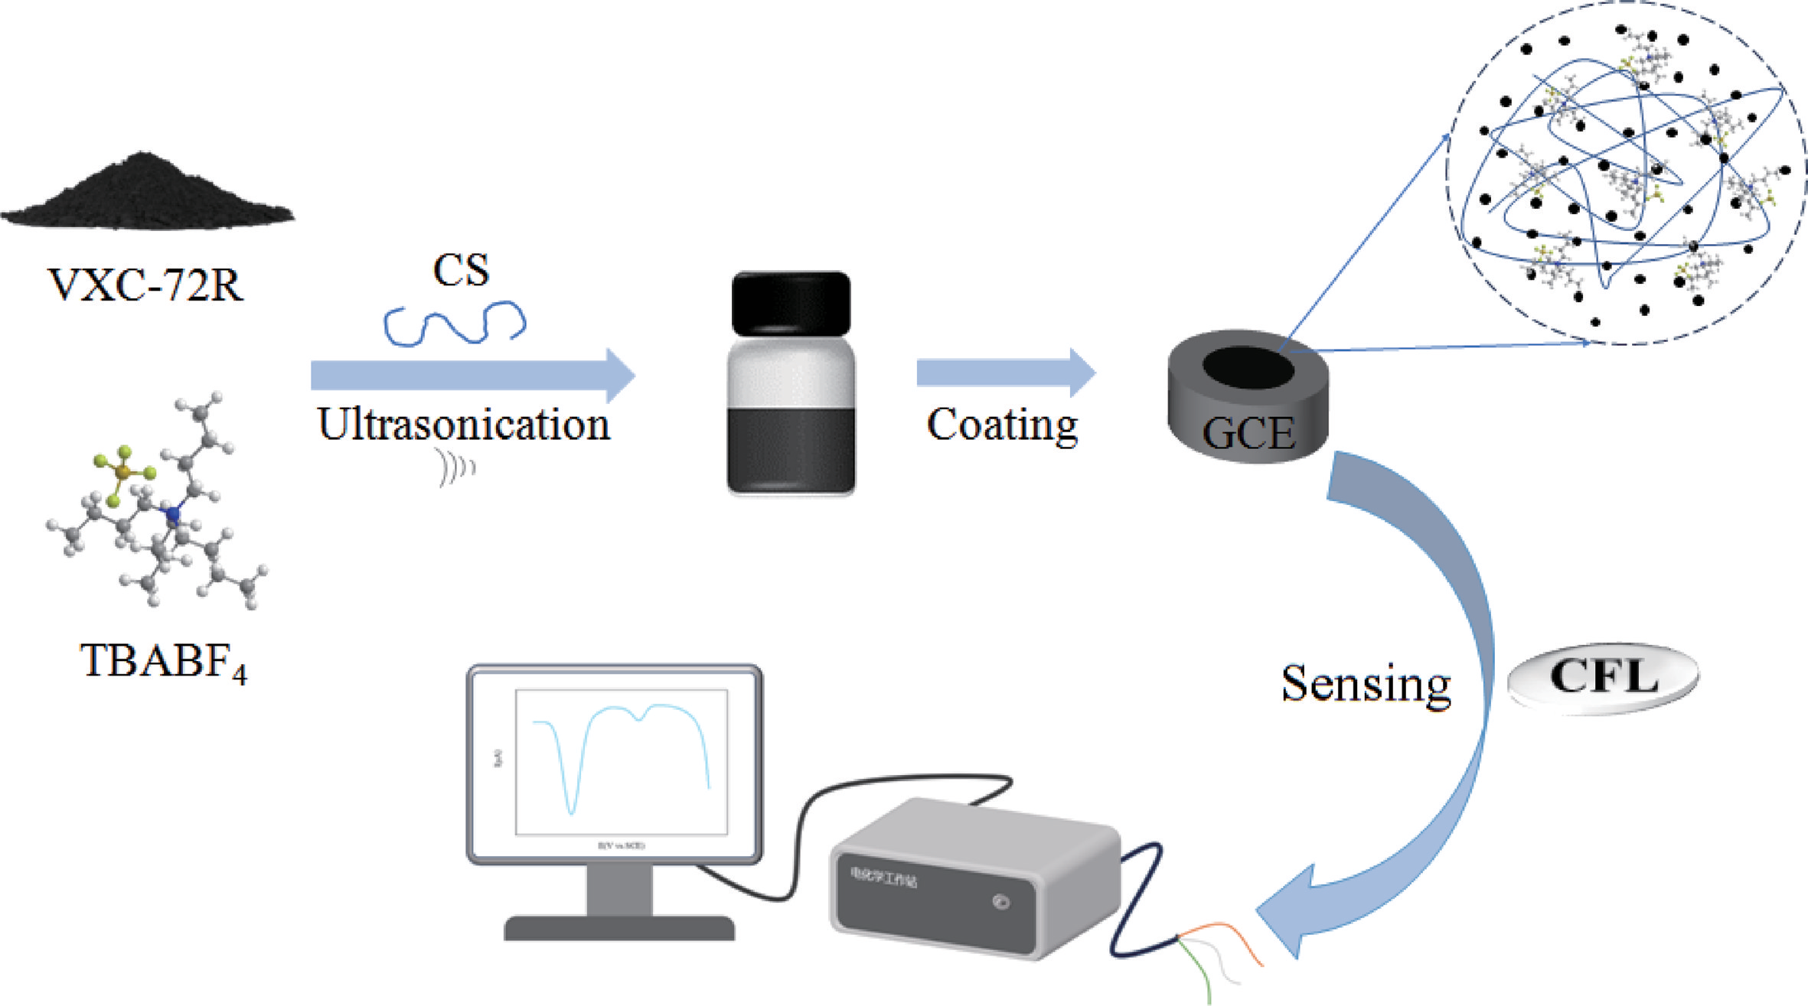
ZHU Zongxian, ZHANG Xuan
Citation: ZHU Z X, ZHANG X. Development of Electrochemical Sensor for Cefadroxil Antibiotic Based on Conductive Carbon Black Decorated with Tetrabutylammonium Tetrafluoroborate [J]. Journal of Donghua University (English Edition), 2025, 42(4): 348-357.

──────────────────────────────
感谢您的阅读！欢迎引用本文内容
© 2025 东华大学学报 版权所有

